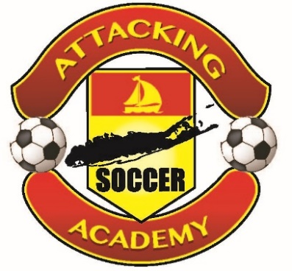

MEDICAL RELEASE FORM

I, ________________________________, PARENT/LEGAL GUARDIAN, OF ________________________ HEREBY AGREE TO INDEMNIFY, DEFEND AND HOLD HARMLESS ATTACKING SOCCER ACADEMY, LTD. (TOGETHER WITH SUCH COMPANY’S SPONSORS, TRAINERS, STAFF, EMPLOYEES, CAMPERS, PARTICIPANTS AND PRINCIPALS) FROM AND AGAINST ANY AND ALL INJURIES THAT MY CHILD MAY SUFFER AS A RESULT OF PARTICIPATION IN ANY ATTACKING SOCCER ACADEMY PROGRAM. I RECOGNIZE THAT SOCCER IS A CONTACT SPORT AND THAT IT MAY BE PHYSICALLY STRESSFUL AND TAXING ON MY CHILD. I FURTHER RECOGNIZE THAT MY CHILD’S PHYSICAL AND MENTAL HEALTH CONDITION MUST BE FULLY COMMUNICATED IN WRITING TO GARY NEMETH OF THE ATTACKING SOCCER ACADEMY, LTD. PRIOR TO MY CHILD’S PARTICIPATION IN ANY OF THEIR PROGRAMS. IF I DO NOT COMMUNICATE ANY OF THIS INFORMATION IN WRITING TO GARY NEMETH OF THE ATTACKING SOCCER ACADEMY, LTD., I WILL BE SOLELY RESPONSIBLE FOR ANY ADVERSE CONSEQUENCES. AS OF THE DATE OF THIS DOCUMENT, MY CHILD IS AFFECTED BY THE FOLLOWING PHYSICAL OR MENTAL HEALTH CONDITIONS: _____________________________________________________________________________________
_______________________________________________________________.

x__________________________________________ Date: __________________
(parent/legal guardian of the above-named participant)

